**Name**: Khushei Meghana Meda

**SRN**: PES1201800416

**Week number**: 9

**Name of experiment**: IPv6 Configuration and Static Routing

**Date**: 8-11-2020

**Objectives of the experiment**:

-Perform basic IPv6 configurations on a Desktop and Router.

-Distinguish between IPv4 and IPv6 addresses

-Configure IPv6 static routes in Router

-Observe traffic flow using IPv6 static routes.

-IPv6 neighbor cache entries

-Understanding IPv6 Link Local Address

-Working with ping6 and tracepath6

**Topology:**

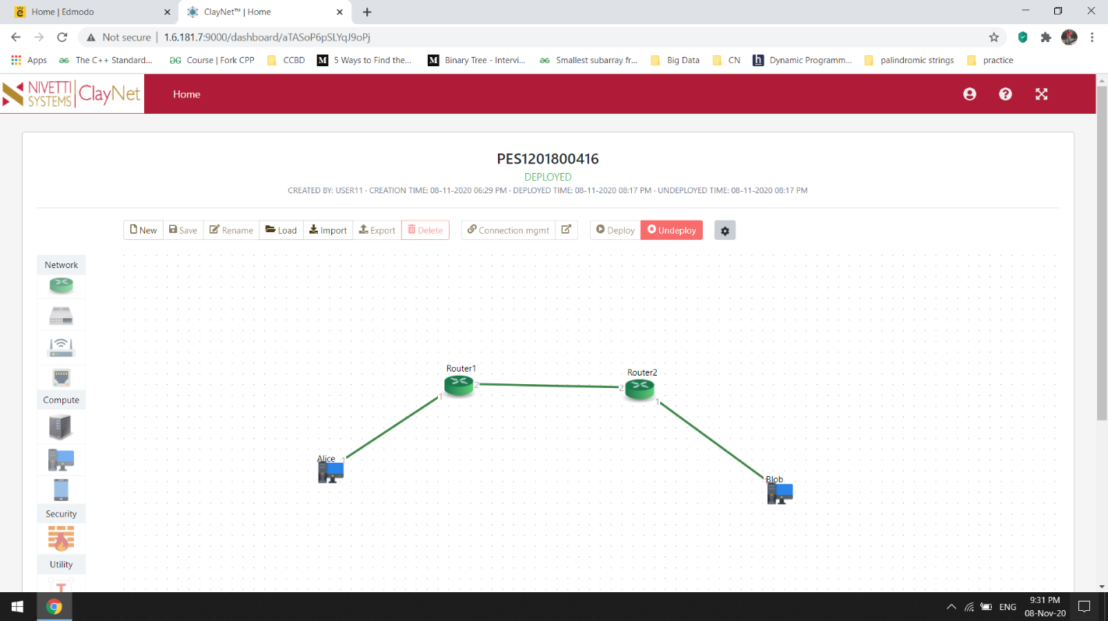

**Verify traffic flow between Alice and Bob:**

* From Alice workstation ping Bob, observe the packet from and TTL in ping reply

* From Alice workstation run tracepath to Bob’s IP. Observer the intermediate hops

Wireshark capture-

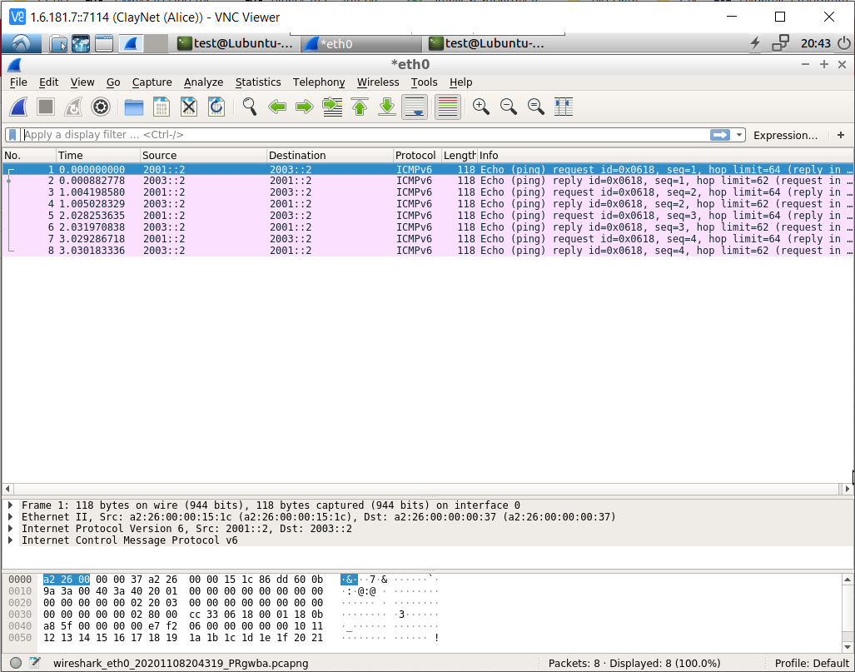

Ping and traceroute-

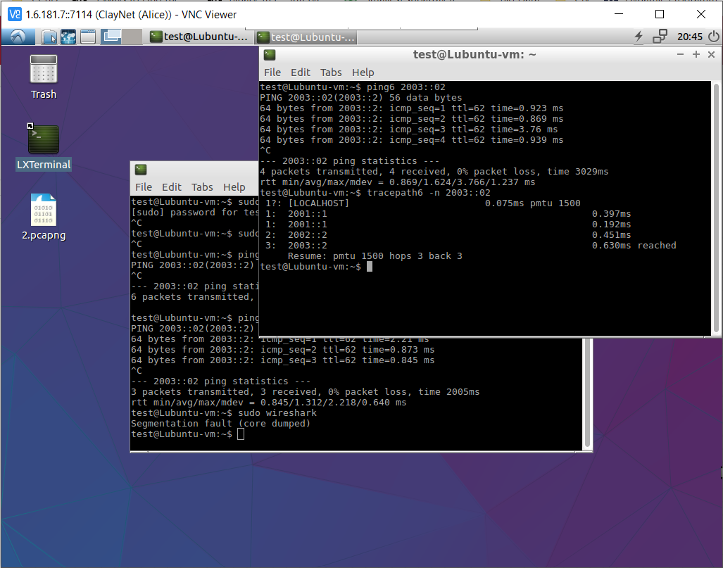

**Check the connectivity between Router-1 and Router-2 using Link Local Address:**

Login to Router-2 and get the link-local address of interface connected to Router

Now, Login to Router-1 and ping the link-local address on Router-2 and observe the response. When pinging link-local address, the the name if out-going interface should be specified in the command. If no interface or wrong interface name is specified, ping will result in error or unsuccessful.

